**Adventure Works data extraction**

1. **First, we need to download Microsoft SQL server to manage our future database.** [**https://www.microsoft.com/es-es/sql-server/sql-server-downloads**](https://www.microsoft.com/es-es/sql-server/sql-server-downloads)

**We chose to download fully local environment to do not spend budget that we do not have.**

1. **Then we need SSMS in order to manipulate with the data. In our case the backup files we got from Microsofts GitHub.** [**https://learn.microsoft.com/en-us/sql/ssms/download-sql-server-management-studio-ssms?view=sql-server-ver16&redirectedfrom=MSDN#download-ssms**](https://learn.microsoft.com/en-us/sql/ssms/download-sql-server-management-studio-ssms?view=sql-server-ver16&redirectedfrom=MSDN#download-ssms)
2. **Now we need to download the most recent Adventure Works backup file.** [**https://github.com/Microsoft/sql-server-samples/releases/tag/adventureworks**](https://github.com/Microsoft/sql-server-samples/releases/tag/adventureworks) **We will be using Data Warehouse version to recieve all the data and be able to process everything in the local environment.**
3. **Thanks to the instructions given to us by Microsoft, we know how to make a backup of the entire database.** [**https://learn.microsoft.com/en-us/sql/samples/adventureworks-install-configure?view=sql-server-ver16&tabs=ssms#download-backup-files**](https://learn.microsoft.com/en-us/sql/samples/adventureworks-install-configure?view=sql-server-ver16&tabs=ssms#download-backup-files)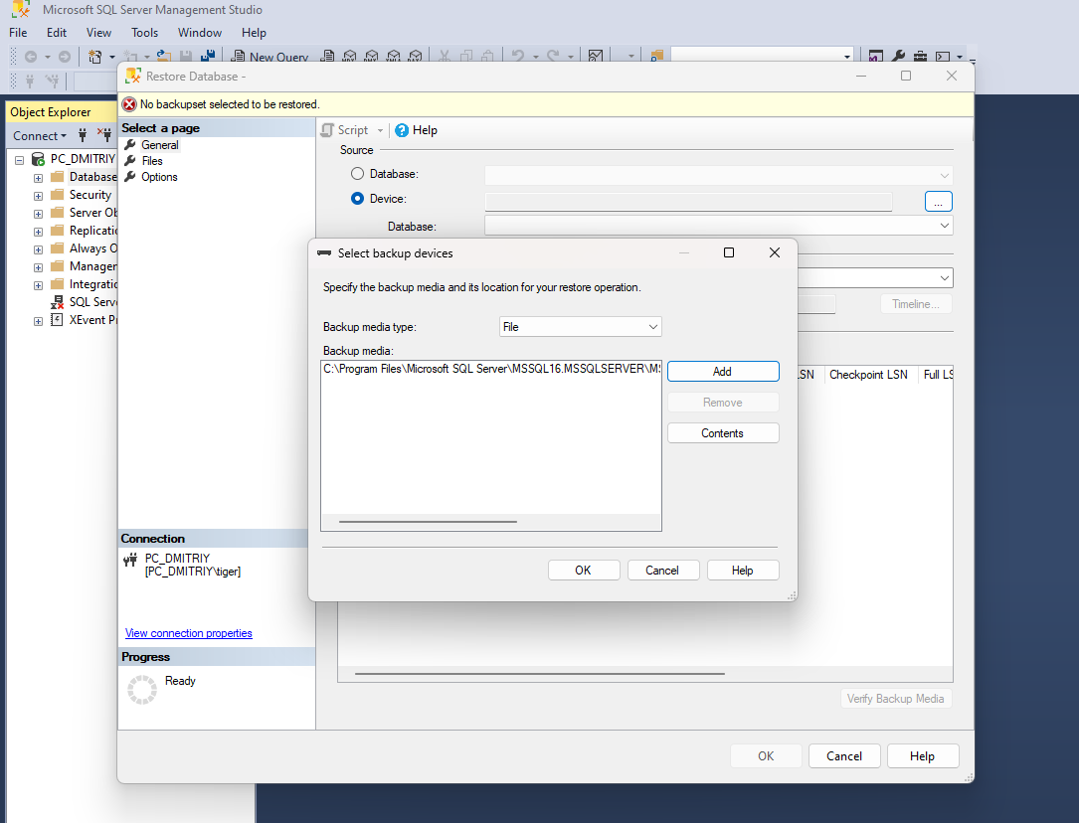

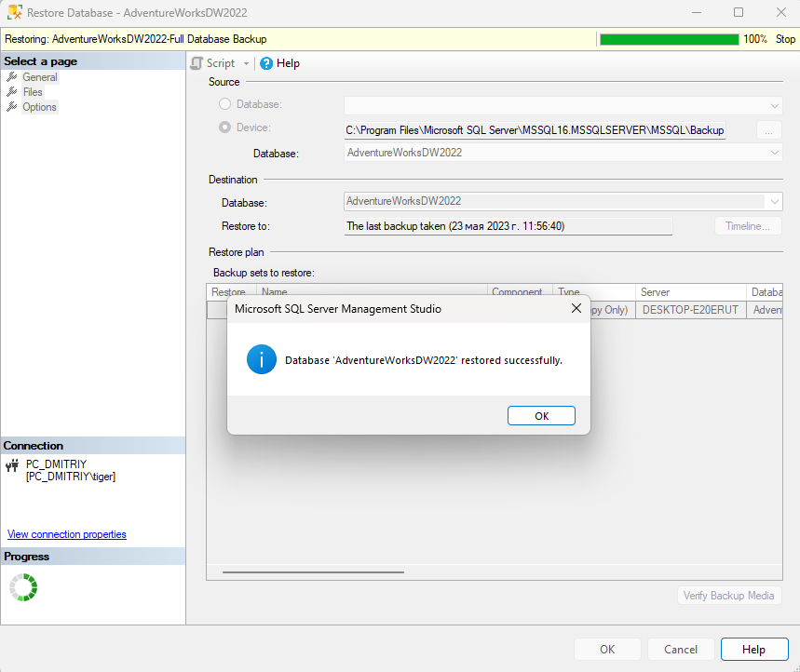

1. After making the backup, we see the entire database, since we only need to data to work with, we do exploratory visual analysis of all the data tables and see what we might need in our project and what we would not.

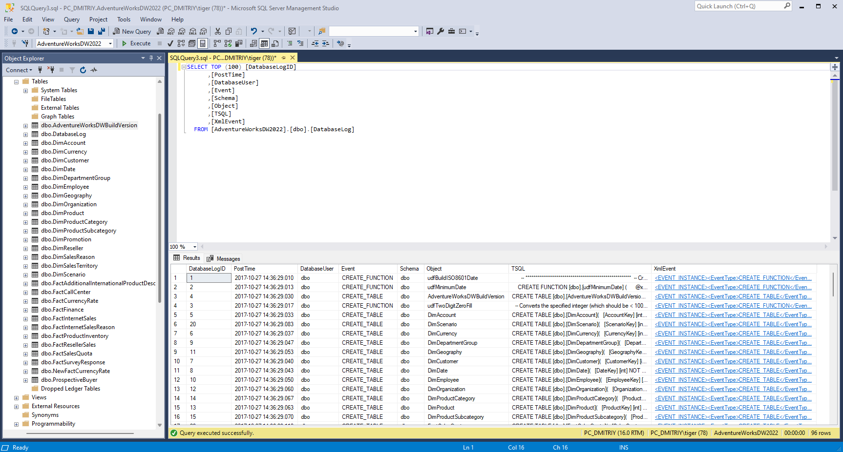

1. AdventureWorksDWBuildVersion – The table with 1 parameter stating the version of the database and the time it was patched. NOT TAKEN

DatabaseLog – History of changes made to different parts of the database stating time, action and user. NOT TAKEN

DimAccount – Type of accounts, their purpose and foreign keys – TAKEN.

1. In order to get the tables as CSV, we downloaded special tool for this purpose <https://docs.devart.com/data-pump/exporting-data/export-to-csv.html>

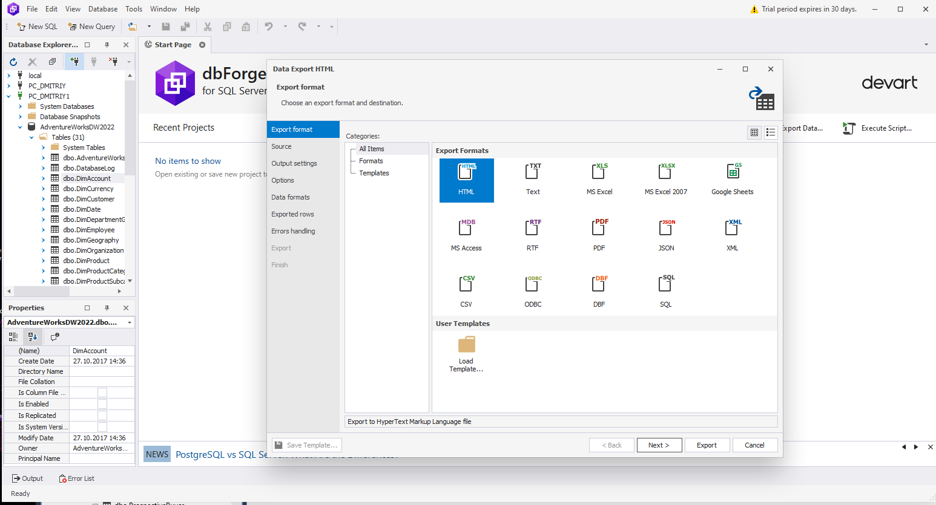

1. After exporting all the data, we get to see all the csv tables we got to work with

